**How does the covid pandemic impact air quality? Looking at the temporal variation in pollutants recorded in NYC**

**Introduction:**

Covid pandemic has been reshaping people’s lives dramatically during the past two years. Shutting down of business and limitation on traveling were two important ways for the governments to control the spread of the virus. There are economic, social, as well as environmental impacts from those covid-related policies. Here I’m interested in learning more about how the covid pandemic impacted air quality in the city area.

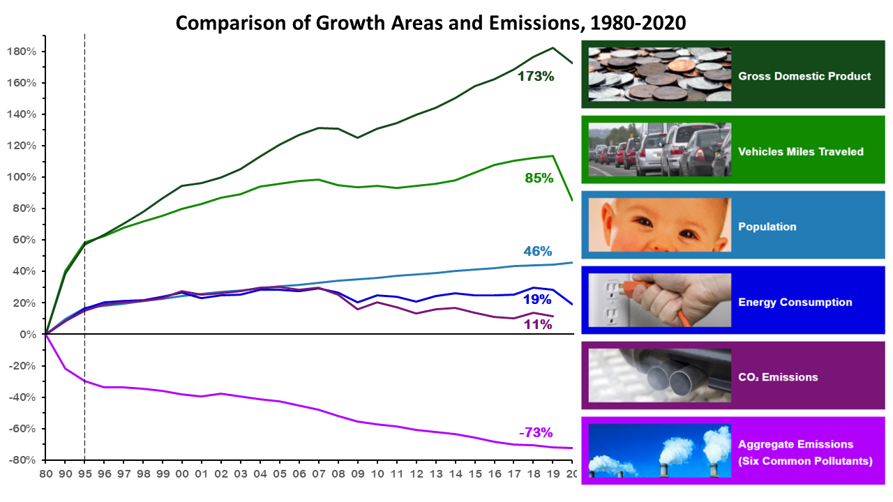

According to this figure from EPA, there is a clear trend that during the pandemic years, vehicles miles traveled and energy consumption decrease dramatically. The same sharp decrease in population mobility was also observed around the world. Multiple research papers on the lockdown’s impact on air quality and air pollution has been published from scientists around the world. Ming, et al. (2021) have found out that during the pandemic, PM 2.5 and Air Quality Index (AQI) in China decreased by about 7 ug/m^3 and 5 points respectively. Zhu et al (2020) used a different approach by correlating the human mobility index and the air quality index and found similar result—human mobility index is positively correlated with air quality index, meaning that the higher the human mobility, the worse the air quality.

Similar trend was found in Korean cities (around 30% reduction in PM 2.5 number; Seo et al., 2020), India (negative anomaly in Aerosol Optical Depth; Gautam, 2020), and multiple other countries (5% and 4% drop in global level of NO2 and PM 2.5 respectively; Dang and Trinh, 2020) and researchers analyzed NO2 and PM 2.5 levels against days before and after lockdown. Almost all of the researchers agree that the most reasonable explanation of this improvement in air quality is the reduction in motor vehicle use as imposed by travel bans.

With these research papers as background, I’ve decided to perform some analysis on air quality of NYC. Using the air quality data (which includes PM 2.5, CO, and NO2 measurements) recorded in sensors in NYC, it would be convenient to plot the pollutants’ concentration against time and see if there are significant dips around the time of the pandemic lockdown.

**Data:**

There will be two important source of data: the national traffic volume data from U.S department of transportation and air quality data in the NYC region from EPA.

*National traffic volume data:*

This data is a monthly report based on hourly traffic count and are collected continuously at approximately 5000 traffic counting locations nationwide. The data sheet was downloaded as a csv file and there are only three columns: time (year and month), vehicle miles travelled (VMT), and seasonally adjusted VMT. Seasonally adjusted VMT would be plotted against time in order to discover possible interesting trends during the pandemic time. Each entry is a sum of VMT and seasonally adjusted VMT in a month. The data entry starts with January 2000 and ends at December 2021.

*Air pollutant data for NYC area (PM 2.5, CO, and NO2)*

These data sheets were downloaded from AirData website, which is an open source data website that publish air quality data collected at outdoor monitors across the US. It is said that the data come primarily from the Air Quality System database.

PM 2.5, CO, and NO2 from NYC area (New York-Newark-Jersey City) in the year 2020 were downloaded as three separate files, each includes one air pollutant, time of collection, site and county name, and site latitude and longitude. Each entry represents a daily average of pollutant of interest starting from January 1st 2020, ending on December 31st 2020. There are in total 9969 entries from various site. PM 2.5 was recorded in ug/m3 with one decimal place. CO was recorded in parts per million with one decimal place. And NO2 was recorded as parts per billion with one decimal place.

**Analysis process:**

My current plan is to plot a graph with time on the x axis and vehicle miles travelled on the y axis to see if there is a dip present during the covid lockdown period. This is likely to involve loading in the csv file into r studio and using the plot function to construct a scatter plot. If there is a dip, then I’m planning to construct a linear model for all the data entries besides where the dip is occurring so that we can have an estimation of what the VMT would be if covid never happened and use that number to calculate the difference between observed and predicted value.

For the pollutants data, I will need to join the three separate datasets by data and site. Once joined, I am planning to plot the three pollutants on the y axis and time on the x axis. It would also be interesting to plot the three pollutants against each other to see if they are correlated. It would be great if we can plot Vehicle Miles Travelled against the pollutant or Air Quality Index. However, the VMT records national total while the air quality data is limited to New York City area. Thus, there may not be any significant or meaningful result. (It is surprising that there is no data on NYC VMT available on the internet. NY state DMV website only have the VMT number for all urbanized area summed.)

Reference:

Dang, H.-A. H., & Trinh, T.-A. (2020). Does the COVID-19 pandemic improve global air quality? new cross-national evidence on its unintended consequences. *SSRN Electronic Journal*. https://doi.org/10.2139/ssrn.3654917

Gautam, S. (2020). The influence of covid-19 on air quality in India: A boon or Inutile. *Bulletin of Environmental Contamination and Toxicology*, *104*(6), 724–726. https://doi.org/10.1007/s00128-020-02877-y

Ming, W., Zhou, Z., Ai, H., Bi, H., & Zhong, Y. (2021). Covid-19 and air quality: Evidence from China. *Research on Pandemics*, 290–310. https://doi.org/10.4324/9781003214687-20

Seo, J. H., Jeon, H. W., Sung, U. J., & Sohn, J.-R. (2020). Impact of the COVID-19 outbreak on air quality in Korea. *Atmosphere*, *11*(10), 1137. https://doi.org/10.3390/atmos11101137

Zhu, Y., Xie, J., Huang, F., & Cao, L. (2020). The mediating effect of air quality on the association between human mobility and covid-19 infection in China. *Environmental Research*, *189*, 109911. https://doi.org/10.1016/j.envres.2020.109911